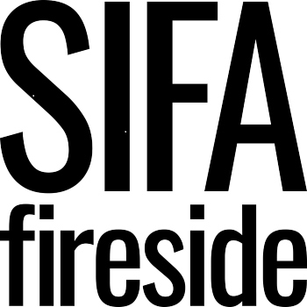

Person Specification
Employability / Step Ahead Project Worker

Criteria | E- Essential  D - Desirable | Assessment
 |  | AF | I | T
QUALIFICATIONS  Accredited qualification(s) in relevant field such as adult social care, mental health, addiction | D | X
KNOWLEDGE, SKILLS, EXPERIENCE  Considerable proven experience of working with vulnerable people and/or people with complex needs  Demonstrable experience of working within the employment / employability sector  A good understanding of the barriers experienced by individuals with experience of homelessness or who are vulnerably housed  Proven knowledge and understanding of adult safeguarding  Experience of developing client journeys and case management approaches  Experience of devising and delivering effective 1-1 and group work sessions  Awareness of current legislation in relation to homelessness and housing  Outstanding communication skills  Excellent organisational skills  Ability to plan and organise workload and casework  Competent IT user including Word, Excel, Outlook, internet  Experience of using a client case management database  Experience of working in the voluntary sector | E  D  E  E  E  E  D  E  E  E  E  D  D | X  X  X  X  X  X  X  X  X  X  X  X  X | X  X  X  X  X  X  X | X  X  X  X
BEHAVIOURS AND PERSONAL ATTRIBUTES  Strong alignment and commitment to organisational values  Works well in a team setting, recognising and embracing the value of differing strengths and approaches within the team.  Ability to uphold good personal boundaries when working with vulnerable people.  Exercises tact and discretion dealing sensitively with challenging situations  Highly energetic with a passion for working with people whose voices are less heard in society  Proactive and able to independently seek out opportunities to improve practice  Highly resilient and able to manage the emotional challenges of working with an extremely vulnerable client group  Able to be resourceful and find creative solutions to problems  Ability to work flexibly | E  E  E  E  E  E  E  E  E | X  X  X  X  X  X  X  X  X | X  X  X  X  X  X  X  X  X | X  X  X  X  X
SPECIAL REQUIREMENTS  Enhanced DBS  Full driving licence  Fluent in language other than English | D  D  D | X  X  X

