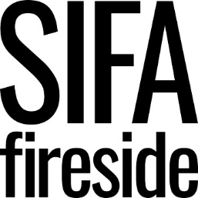

Person Specification
Crisis Project Worker

Criteria | E- Essential  D - Desirable | Assessment
 |  | AF | I | T
QUALIFICATIONS  NVQ 2 or above in Information Advice & Guidance  NVQ 3 or above in Health & Social Care | D  D | X  X
KNOWLEDGE, SKILLS, EXPERIENCE  Proven experience of working with vulnerable people and/or people with complex needs  Strong understanding of barriers experienced by individuals with experience of homelessness or who are vulnerably housed  Evidence of specific expertise in relation to, or a good understanding of, addiction, mental health, or trauma informed practice.  Experience of working within a team  Excellent communication skills  Excellent organisational skills  Liaison and networking skills, including in multi-agency environments.  Evidence of previous experience in using In-Form or similar client management database.  Experience of collating and reporting statistics and outcomes.  Competent IT user including Word, Excel, Outlook, Internet and other online packages.  Skills in a relevant community language.  PIE (psychologically informed environments) trained | E  E  E  E  E  E  E  E  D  E  D  D | X  X  X  X  X  X  X  X  X  X  X  X | X  X  X  X  X  X  X | X  X  X  X  X  X
BEHAVIOURS AND PERSONAL ATTRIBUTES  A proactive and resilient approach  Ability to use own initiative  Ability to plan and organise workload and casework  Commitment to anti-oppressive practice  Committed to promoting our core values in all areas of work: supportive, courageous, dynamic, inclusive  Flexible approach to working hours | E  E  E  E  E  E | X  X  X  X  X  X | X  X  X  X  X | X  X  X
SPECIAL REQUIREMENTS  Enhanced DBS | E | X

