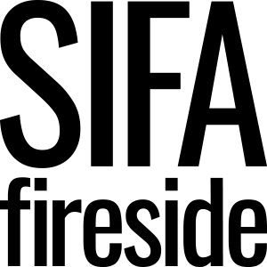

Application Form

Code/Ref :_____________

Position applied for:
Where did you hear of this post?

Personal details

Forename(s) | Surname
Title (Mr, Mrs, Miss, Ms etc) | Previous Names (if any)
Address | Telephone:  Email:

Do you have the right to take up employment in the UK? Yes/No

Do you require a work permit? Yes/No

Driving Licence: Do you hold a current UK Driving Licence? Yes/No

If you are disabled, please give details of any special arrangements you would require to attend an interview:

Please give the names and address of two referees (not related to you); one should be your current or last employer. Please indicate any that you do not wish taken up at this stage. Please note that current SIFA Fireside staff cannot act as referees.

  Name
  Position
  Organization
  Address
  Post Code
  Tel No
  Email
  Do you consent to a post interview reference request? |  | Y N
  Name
  Position
  Organization
  Address
  Post Code
  Tel No
  Email
  Do you consent to a post interview reference request? |  | Y N

FOR OFFICE USE ONLY

Date Received: _______________

S/L
I
A

General education

Dates | Establishment | Qualifications

Any relevant training courses

Date | Course | Qualification if applicable

Professional qualification/registration

Qualifications | Dates | Ref No | Renewal

Current/last employment

Name of Current Employer | Dates | Job Title | Reason for Leaving

Current Salary | Notice Period | Description of Duties

Previous employment

Name | Dates | Job Title | Reason for Leaving

Please give details of, and provide an explanation for any time when you were not either working or in full time education:

Additional Information

The information you provide in this section will be used in assessing your application. Please use this space to your full potential to demonstrate through actual examples of how your skills, knowledge, experiences and behaviours match the job description and personal specification.

Any further Information

Rehabilitation of Offenders Act 1974

Do you have any current or previous convictions or cautions? Yes No

If yes, please give details:

We accept applications from individuals who have experienced previous problems with drink or drugs.

We require that you have achieved a period of abstinence of at least 2 years and have a permanent residence.

Declaration:
I declare that the information I have given on this form is to the best of my knowledge, true and complete. I understand that if it is subsequently discovered any statement is false or misleading, or that I have withheld relevant information, my application may be disqualified, or if I have been appointed I may be dismissed. I give my consent to SIFA Fireside processing the data supplied on this application form for the purpose of recruitment and selection.

Signature |  | Date

