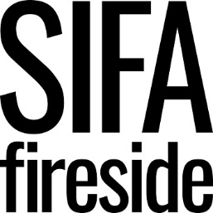

Person Specification
Activities Co-ordinator

“SIFA Fireside is committed to inclusive employment practices and we are particularly interested in applications from individuals who have lived experience of the issues our organisation addresses.
We encourage applicants to think creatively about how they can meet the requirements of the person specification. We are looking for talented individuals who align with our values and support our mission – there are no barriers to how you demonstrate this”.

Criteria | E- Essential  D - Desirable | Assessment
 |  | AF | I | T
QUALIFICATIONS  Evidence of experience in supporting vulnerable/marginalised groups or of working in an arts and community setting. Candidates without degrees but a higher level of vocational experience will be considered.  Minimum of one year’s experience of working within an arts or community setting.  Experience of facilitating activities in community settings.  Experience of volunteering or working with volunteers. | D  E  E  D
KNOWLEDGE, SKILLS, EXPERIENCE  Confidence to engage directly with clients and encourage and motivate them to participate in activities and events.  Excellent organiser and coordinator.  Excellent communication skills both verbal and written.  Strong administrative skills and proficient in Microsoft Office.  Good writing skills with the ability to write evaluations, reports and develop valued contacts.  Ability to prioritise effectively and enjoy multi-tasking in a busy environment.  Excellent team player.  A strong believer in our organisation’s values of Supportive, Inclusive, Dynamic and Courageous. | E  E  E  D  D  D  E  D
BEHAVIOURS AND PERSONAL ATTRIBUTES  A strong believer in enabling homeless and vulnerable people to take back control and live healthy and fulfilling lives.  Friendly, cheerful, positive and motivated.  Caring and supportive to others.  Self-motivated and enjoy working as part of a team.  Passionate about the importance of communities in supporting people.  Creative and innovative in your approach. | D  E  E  E  E  D
SPECIAL REQUIREMENTS  Use of a car would be desirable but not essential. | D

