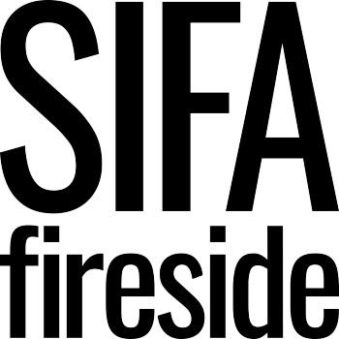

Equality and Diversity Monitoring Form

We are committed to equal opportunities in our recruitment process and in order to find out how well we are doing with this we collect monitoring data. This monitoring form is voluntary but the information we collect here is very useful to us as it helps us to make sure that we are an inclusive employer and to find out if our workforce is diverse. The information you supply on this form will be kept confidentially. The monitoring form is not sent to the recruiting panel and has no part in the shortlisting process.

How did you find out about this post?
SIFA Fireside website
Online publication/job-board (please state):
Printed publication (please state):
Agency (please state):
Email network (please state):
Social media (please state):
Other (please state):

Your ethnic origin

Asian or Asian British
Asian / Asian British – Indian
Asian / Asian British - Pakistani
Asian / Asian British - Bangladeshi
Asian / Asian British – Chinese
Asian / Asian British – Other (specify if you wish):
Black, African, Caribbean or Black British
Black, African, Caribbean or Black British - African
Black, African, Caribbean or Black British - Caribbean
Black, African, Caribbean or Black British - Other (specify if you wish):
Mixed Multiple Ethnic Groups
White and Asian
White and Black African
White and Black Caribbean
White and Chinese
Other (specify if you wish):

White
White - British
White - English
White - Scottish
White - Welsh
White - Irish
White - Northern Irish
White - Other (specify if you wish):

Other ethnic group
Arab
Latin American
White – Gypsy, or Irish Traveller
Roma
Central and Eastern European
Western and Southern European
Other ethnic group (specify if you wish):

Prefer not to say

Your gender
Male Female Intersex Prefer not to say
Gender Identity
Cisgender Transgender Non-binary Prefer not to say

If you prefer to use your own gender identity, please state:

Your age
18 - 24 25 - 29 30-34 35-39 40-44 45-49

50-54 55-59 60-64 65+ Prefer not to say

Your sexual orientation
Bisexual
Gay
Lesbian
Heterosexual
Asexual
Unsure
Prefer not to say
If you prefer to use your own identity, please state:

Marriage and civil partnership
Single
Married/in a registered civil partnership
Separated, but still legally married/in a registered civil partnership
Divorced/formerly in a same-sex civil partnership which is now legally dissolved
Widowed/Surviving partner from civil partnership
Prefer not to say

Your religion or belief
Agnostic  Atheist  Buddhist  Christian (including Church of England, Catholic, Protestant and all other Christian denominations)  Hindu | Jewish  Muslim  Sikh  Other (specify if you wish):  Prefer not to say

Disability
The Equality Act 2010 defines a disabled person as someone who has a physical or mental impairment which has a substantial and long-term adverse affect on their ability to carry out normal day-to-day activities.

Do you consider yourself to have a disability or health condition?
Yes (specify if you wish):
No
Prefer not to say

Please return this form along with your completed application form to xxx

