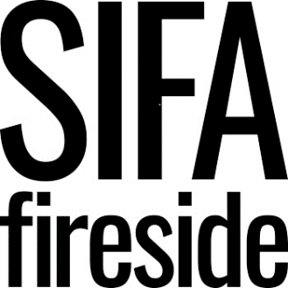

Person Specification
Intervention Assessment Worker

Criteria | E- Essential  D - Desirable | Assessment
 |  | AF | I | T
QUALIFICATIONS  NVQ 2 or above in Information Advice & Guidance  NVQ 3 or above in Health & Social Care | D  D | X  X
KNOWLEDGE, SKILLS, EXPERIENCE  Proven experience of working with vulnerable people and/or people with multiple and complex needs  Strong understanding of the multiple barriers experienced by individuals with experience of homelessness or who are vulnerably housed.  Awareness of harm reduction principles and how these might be applied through this work.  Understanding of some of the needs of our client group including homelessness, addiction, mental health or criminal justice system.  Awareness of trauma informed working principles and psychologically informed environments.  Experience of working collaboratively within a team and with partner organisations and agencies  Excellent communication skills  Excellent organisational skills and ability to manage caseload of clients  IT competency including Word, Excel, Outlook and Internet alongside our inhouse client management database.  Experience of collating and reporting statistics and outcomes around your case work. | E  E  E  E  D  E  E  E  D  D | X  X  X  X  X  X  X  X  X  X | X  X  X  X  X  X  X | X  X  X  X  X
BEHAVIOURS AND PERSONAL ATTRIBUTES  A proactive and resilient approach  Ability to use own initiative  Ability to plan and organise workload and casework  Commitment to anti-oppressive practice  Committed to promoting our core values in all areas of work: supportive, courageous, dynamic, inclusive  Flexible approach to working hours | E  E  E  E  E  E | X  X  X  X  X  X | X  X  X  X  X | X  X  X
SPECIAL REQUIREMENTS  Enhanced DBS | E | X

