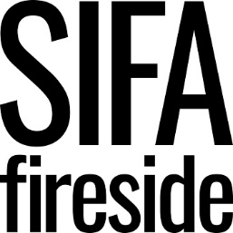

Person Specification
Facilities Assistant

SIFA Fireside is committed to inclusive employment practices and we are particularly interested in applications from individuals who have lived experience of the issues our clients face. We encourage applicants to think creatively about how they can meet the requirements of the person specification. We are looking for talented individuals who align with our values and support our vision and mission – there are no barriers to how you demonstrate this.

Criteria |  | Assessment
Criteria | E-Essential  D-Desirable | Application | Interview | Task
KNOWLEDGE, SKILLS, EXPERIENCE
- Proven experience of facilities and / or building management | E
- Understanding operational risk as it relates to facilities and maintenance | E
- Good knowledge of Health & Safety | D
- Ability to prioritise, plan and organise workload. | E
- Competent user of Microsoft Office package and general IT | E
- Understanding of and commitment to maintain confidentiality and professional boundaries at all times | E
- Outstanding communication skills | E
- Excellent organisational skills | E
- Excellent people and customer service skills | E
- Experience of working in the voluntary sector | D
- Experience of working within a building utilised by the public | D
BEHAVIOURS AND PERSONAL ATTRIBUTES

- Committed to making a difference to the lives of people experiencing or at risk of homelessness as outlined in the strategic plan. | E
- Strong alignment and commitment to organisational values | E
- Works well in a team setting, recognising and embracing the value of differing strengths and approaches within the team. | E
- Demonstrates resilience when dealing with the emotional challenges of working with an extremely vulnerable client group within a complex setting. | E
- Creativity and enthusiasm with a positive, solution-focused attitude. | E
- Commitment to equality, diversity and inclusion and ability to incorporate this into practice. | E
- Adherence to SIFA Fireside’s vision and values. | E
- Ability to work flexibly. | E
QUALIFICATIONS
- Working Safely or Managing Safely IOSH qualification | D
- Recognised trade qualification in Maintenance, such as mechanical, electrical & carpentry | D
SPECIAL REQUIREMENTS

Enhanced DBS | E

